BINDJAREB PINJARRA
Marketing & Information Pack
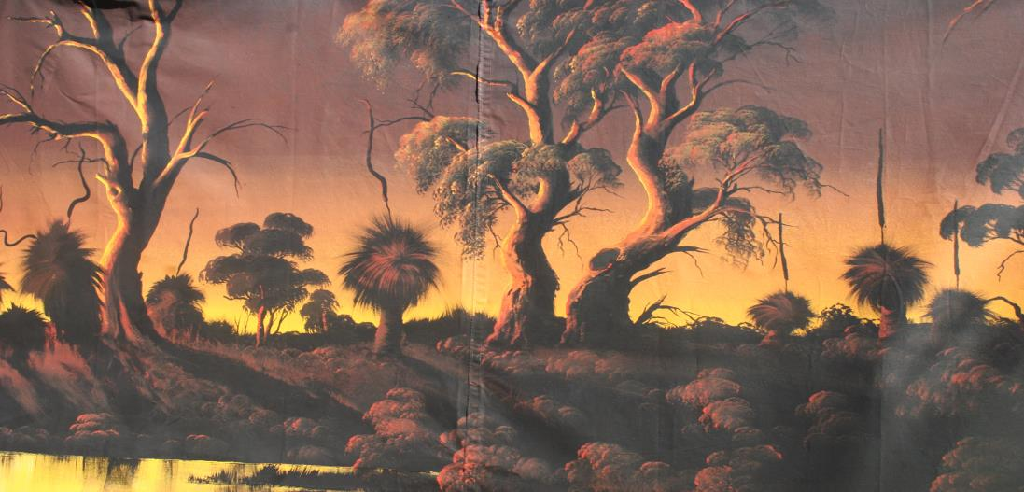

Our play Bindjareb Pinjarra explores the black & white history of the Pinjarra Massacre of 1834 and follows Roland Mission, a modern-day young Nyoongar man, as he learns about his connection to that history.
Created and performed by Nyoongar (indigenous) and Wadjella (whitefella) actors Bindjareb Pinjarra switches from the past to the present to reveal, with irreverent humour and satire, how prejudices of earlier times are still very much part of our modern lives.
Although the play recounts one of the bloodiest days in Western Australian history it remarkably manages to be one of the funniest shows you’ll ever see. The comedy is not disrespectful and our play has the full support of the Pinjarra Nyoongar Community.
Like real life, Bindjareb Pinjarra is a mixture of tears and laughter. Laughter brings people closer together, and the comedy in Bindjareb Pinjarra brings the audience closer to the heart of the play – the covered-up history of our country.
By admitting past horrors, and by sharing laughter and grief together, our play demonstrates how reconciliation can work. Bindjareb Pinjarra is black and white Australians working together onstage, truly united in a spirit of mutual understanding, inspiring all Australians to get together to create a better future as one people.
Bindjareb Pinjarra is WA’s longest running theatre production (over 340 performances). First performed in 1994 this unique and iconic work about the Pinjarra Massacre has toured extensively throughout Australia and garnered great reviews and ovations.

This is reconciliation theatre at its best
Rhoda Roberts, The Dreaming Festival

BINDJAREB PINJARRA
A selection of reviews
I can’t praise Bindjareb Pinjarra highly enough. It may be the most effective vehicle for black-white reconciliation you’ll ever see... and it’s a wonderful theatre experience. Brisbane Courier Mail
Extraordinarily immediate, powerful and moving; this is storytelling at its best... highly energised, totally alive drama... a profound test of any art lies in its ability to challenge certainty... has succeeded extravagantly... delicious satire. The West Australian
The strength of this play lies in its ability to alternate and fuse the comic with the tragic, while saying something immensely important about Aboriginal perception of white culture. Financial Review
This is an extremely rewarding piece of theatre, with quite brilliant performances. Subiaco Post
A wonderful fusion of the comic (and the comedy is very funny) with the tragic... Bindjareb tells us about our past. And we grieve. But then it offers us a powerful paradigm for our future. And we hope. Sydney Morning Herald
The ensemble of six male actors are all agile performers and accomplished improvisers and very funny too, because this play about a massacre is presented as a comedy with a black undercurrent. The humour is always deadly serious. Real Time
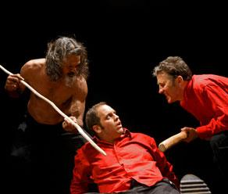

BINDJAREB PINJARRA
A selection of unsolicited emailed responses

It was deadly.
Iliapi Taoi, Architect, Perth
The Staffroom buzz about Bindjareb Pinjarra will rival the post weekend football replays
Clement Mulcahy, Catholic Education Office
Congratulations - it is great to see theatre engaging people so directly and I thought the cast was exceptionally good.
Shelagh Magadza, Artistic Director Perth International Arts Festival
My jaw bones still aching from the laughter.
Jon Doust, Miles Franklin Shortlisted Author and comedian
I saw BINDJAREB with my 13yo son and it was just brilliant. It was, aside from the serious messages, very, very funny.
Brendon Cant, Brendon Cant & Associates
I was so impressed… not only entertained but informed,
Louise Howden-Smith, Former Executive Director, WA Ballet
It was simply awesome!
Michelle Drabarek, Sponsorship Manager, RTRFM 92.1
Everyone is raving about it, a great success all round – very funny and interactive, handling a sensitive subject very well!
Louanne Munz, bhpbiliton
That was such an amazing play. Wow - sad, funny and eye opening all at once. Well-done and thank you so much
Alma Sarhan, Director Bellydance Oasis
Loved it! Important, entertaining – very clever
Helen Curtis, City of Perth
Fantastic! A brilliant balance between being immensely funny and emotionally engaging. Congratulations!
Jessica Matthews, Staff writer Scoop Publishing
Loved it. Absolutely brilliant.
Paula Silbert, Arts Consultant
Students enjoyed the acting, humour and irreverence; and how easily the actors set up a scenario with such a small amount of props. A very worthwhile educational excursion.
Sheila O'Callaghan, Our Lady of Good Counsel School
I was deeply touched by the story and the skilful way the actors presented the information and involved the audience. I felt that I had been educated and emotionally challenged on a level that I haven't experience before by a stage event. In between the serious moments the actors had us in fits of laughter. Highly recommended!
Kathleen Brisbane, Audience Member on Wave Magazine Website
BINDJAREB PINJARRA
For communities and schools
The flexible nature of the play allows the cast to tailor performances for specific audiences. We are able to shorten the work if required and ensure that it is suitable for specific ages (no swear words for primary students, a few choice extra ones for High Schools). The work has been performed in isolated and Indigenous communities, in major performing art centres and festivals, schools and community halls.
“Bindjareb Pinjarra” has been employed over the last 3 years as a training tool for the W.A. Department of Education, and the W.A. Department of Communities. This show is of interest to far more people than just theatre lovers. There is professional interest in this production in health, legal, educational and local government areas.
This is a great opportunity to attract new community members into your venue. The subject matter, the brazen concept of a “comedy about a massacre” and the show’s history guarantees local media interest. Our cast are always available to give lively interviews that will appeal to the sceptical and disinterested.
We have developed marketing techniques (centring on Mob Group Booking Specials and Indigenous cultural and community centres) that help presenters to attract a culturally diverse audience mix. This helps bring out the laughter early, and inevitably leads to a great sense of community unity post-show.
The whole production was amazingly well adapted to meet the needs of students. The production raised as many questions as it answered, a very positive aspect and we are still doing follow up activities with classes in library, music and regular classroom lessons. Students enjoyed the acting skills, the humour and irreverence; and were very taken with how easily the actors were able to set up a scenario with such a small amount of props. The short question and answer session at the end was valuable. It was an excellent production and a very worthwhile educational excursion.
Sheila O'Callaghan, Our Lady of Good Counsel School

This was the best show I have ever brought my students to.
Head of English, Brisbane Boys College

You have succeeded in one hour to bring to life and meaning what I have struggled to communicate in a year
Indigenous Studies Teacher, Mt Barker Agricultural College

BINDJAREB PINJARRA
A comedy about a massacre?
Rest assured that this work demonstrates respect to the memory of the Nyoongar people who were killed and to the continual struggle of the First People of Australia. We received a total blessing from Nyoongar elders who were guests at our preview showing and have support and permission from the Nyoongar Land and Sea Council. This latest version was created on request of the Pinjarra Nyoongar community to help them commemorate the 175th anniversary of the massacre. Obviously this would not be so if the show were inappropriate.
One of our performers is Franklyn Nannup, a widely respected Nyoongar elder (the Chair of the Winjan Aboriginal Centre) and a descendant of survivors of the massacre. He would not tolerate any disrespect in this play.
So why is the play a comedy? If our play only told the sad and bloody truth about what happened at Pinjarra it would make for very difficult viewing and attract only small audiences. We wished to create a popular work, suitable for families and people of all races and backgrounds, so that the hidden history of our country can be shared to many.
We believe that by admitting past horrors and sharing simple laughter and grief, reconciliation comes closer. We believe that black and white Australians working together, as we do in this play, can build a better present and a better future for us all. Over 340 performances throughout Australia in large theatres, schools and isolated communities have proved the success of our approach. Indigenous people in the audience do not feel disrespected and the non-indigenous are not made to feel guilty. We always bring audiences together in a spirit of mutual understanding.
We understand that this may be difficult to understand without reading a script, but there is no written-down script (we made the play using the traditional storytelling techniques of improvisation and memory). However our promotional DVD demonstrates how the show is both hilarious and honourable, and a two-camera shoot of an entire performance can also be provided if local elders or management committees remain concerned.
Immediately after each performance we stay with the audience so they can ask questions about why and how we made the play, and express their thoughts and feelings. Often, local stories are shared about similar tragedies, reminding us all that what occurred in Pinjarra was repeated throughout our nation, and the world.
Kelton Pell, Geoff Kelso, Phil Thomson, Ian Wilkes, Sam Longley, Franklyn Nannup, Trevor Parfitt,
Creators of Bindjareb Pinjarra

Bindjareb Pinjarra
Tech Requirements
SET
A 10m X 2m backdrop/painting to be hung on bar towards the rear of playing area, with enough space behind for props table and for actors to cross.
Props tables and blue lights behind backdrop
Four chairs (or 2 benches) onstage
COSTUME
Company self-contained. An iron and hangers in dressing room. Access to washing machine if multiple performances.
SOUND
House speakers with computer interface
Radio mike or similar for audience questions in large auditoria

LIGHTING
General wash onstage, in straw and blue
White and red lights on backdrop
Front stage lighting
2 specials mid stage, one to left, one to right
Special on sun painted on backdrop.
House lights used during show at times.
DRESSING ROOM
Big enough for 5 actors
STAGE ACCESS
All staging is easily carriable, don’t need truck entrance.

