Media Release

Feeling Good – Music to feed your soul.

A warm and engaging performance, where the music reaches in and gives your heart a good massage and then wraps its arms around you for a big hug and leaves you – feeling good.
Feeling Good is the new show from Sue Bluck’s Quartet that affectionately highlights the lives and music of some of the world’s favourite female piano-playing singers. The artists range from jazz greats Peggy Lee, Nina Simone and Diana Krall to pop diva Carole King and the sublime Norah Jones.

With sophisticated cabaret styling Sue Bluck’s Quartet brings to life the emotions and lifelong passions of these amazing women.
Anecdotal snippets and stories weave through the show giving an insight into the lives, beliefs, challenges and contributions of these amazing women.
Feeling Good is an uplifting enjoyable celebration of wonderful music performed with heartfelt respect and skill by a group of seasoned West Australian professional musicians.

Show credits:
Sue Bluck, piano, vocals and Musical Director
John Pin, guitar and vocals
Joe Powell, bass and vocals
Garry Howard, drums and vocals

ARTIST PROFILES
SUE BLUCK – MUSICAL DIRECTOR, PIANO, VOCALS
Sue Bluck is a keyboard player and vocalist from Perth, who studied in WA and at the Sydney Conservatorium of Music NSW.
Sue has consolidated her place as an accomplished musician/singer/composer and educator in the music industry in Perth and Sydney. She has supported and toured with many artists, and enjoyed piano residencies in 5 Star establishments throughout Australia.
Sue has recorded two albums of original material of her own, sung many jingles, played and sung on albums and performed at numerous concerts, festivals, events and functions.
Currently Sue teaches at the Western Australian Academy of Performing Arts (WAAPA) in the Contemporary Music and Music Theatre Departments.
JOSEPH POWELL – BASS
As an artist and session bass player Joseph Powell has built a reputation in Perth by performing in contemporary funk, soul, RNB, hip hop, rock, country, indie, folk, blues, and jazz fusion bands. As well as recording bass for numerous local artists, he has supported big name Australian acts such as The Hoodoo Gurus, James Raine, Nathaniel, Johnny Ruffo, Shannon Noll, Samantha Jade, Eskimo Joe and The Rubens.
He is also gaining recognition as an excellent educator as part of the sessional lecturing staff at WAAPA.
GARRY HOWARD - DRUMS
Garry spent most of his earlier working days in his hometown of Melbourne playing the pub and club scene. During that time, he enjoyed back to back no 1 hits with The Mixtures (In the summertime / The Pushbike song.)
Moving to Perth in the mid 80’s, he has played with some of the great visiting Jazz and Blues artists including - Jimmy Witherspoon, Barney Kessel, Shelia Jordan, James Morrison and many local acts including Helen Matthews, and is a regular invited drummer to many concerts at The Perth Blues Club.
JOHN PIN – GUITAR
John is a jazz guitarist from Perth, Western Australia and holds a Bachelor of Music Degree and is a graduate of the Musician’s Institute in Los Angeles.
During the 90’s he was a Jazz faculty member of the Western Australian Conservatorium of Music until relocating to Sydney in 1998 during which time he worked as composer and producer for projects including PC Game soundtracks, Production Music, and Music for Film & Television. His works have been signed by BMG, Universal and Zomba Publishing.
His first love is playing guitar and his commitment as a performer and educator has always been at the core of his eclectic career. John returned to Perth in 2013 and currently lectures within the Contemporary and Jazz Music departments of the West Australian Academy of Performing Arts.
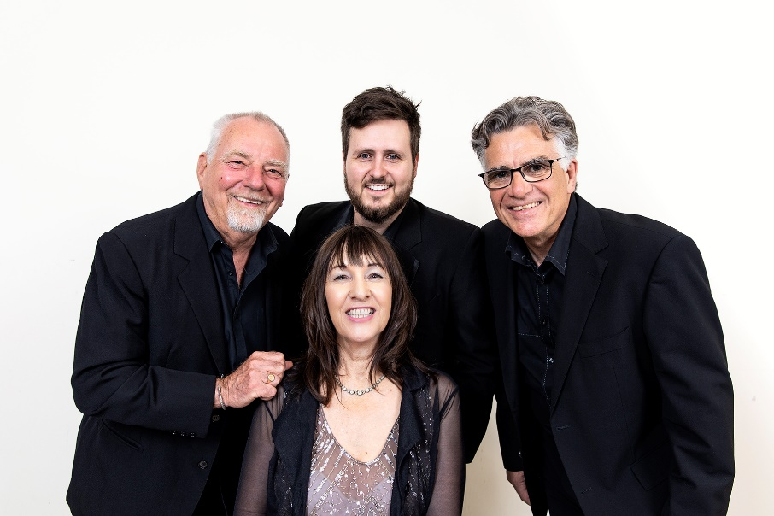
-Release ends-

L to R Garry Howard, Joseph Powell, John Pin and front Sue Bluck.
For interviews, photographs and more information please contact
Producer Pippa Davis on 0408 907 675 or pippadavis57@gmail.com

